Pre-school and Pre-K 2023-2024 School Supply List
- Full-sized backpack- Labeled with child’s name
- Lunchbox for snack- Labeled with child’s name
(If you send in a water bottle, please label with your child’s name)
- Full set of change of clothes- Labeled in a bag with child’s name
- *Velcro Diapers, Velcro Pull-Ups if potty training and wipes if needed
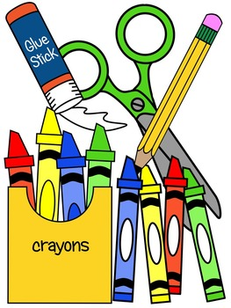
- Washable crayons
- Pack of glue sticks
- Tissue Packs
- Liquid Hand Soaps
Pre-Kindergarten ONLY
- Pencil box- Labeled with child’s name
- 1 spiral notebook
- Washable Markers
- Pencils
In addition, we also frequently use the items below in the classroom.
Any contribution would be greatly appreciated!

- Clorox sanitizing wipes
- Paper towels rolls
- Sandwich and Gallon size Ziploc bags
- White Paper plates (not glossy or Styrofoam)
- Hand Sanitizer

